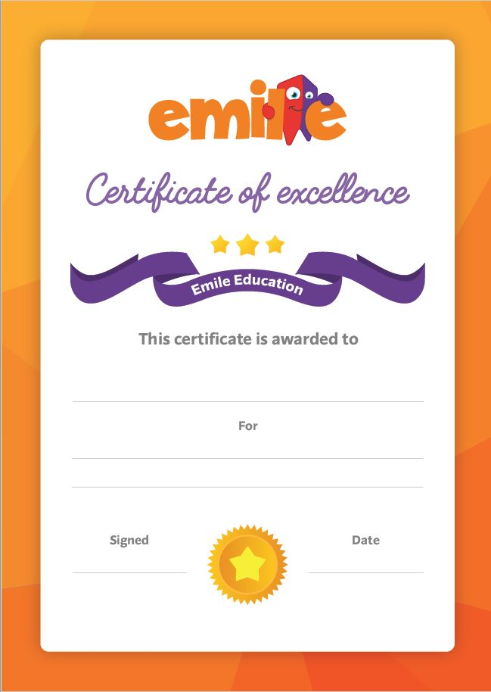

30th September 2019

and succeeding.

Not giving up when faced with a difficult game

Student Name